

# Python Programming Essentials

18B11Cl314

**REPORT on TKINTER PROJECT**

# Message Encryption Decryption using Python

Submitted to: **Dr. Naveen Jaglan**

**Associate Professor**

**Juit Waknaghat**

Submitted by: Yuvraj Khanna

211487 CS38

**Dated: 1/12/22**

# 

# INDEX

| S. No | Title | Page | Dated |
| --- | --- | --- | --- |
| 1 | INDEX | 2 |  |
| 2 | Introduction  About message encryption | 3 |  |
| 3 | Project Details  Project File Structure  1. Importing the Module:  2. Creating the GUI:  3. Encryption Function:  4. Decryption Function: | 5 | 01/12/22 |
| 4 | Python Message Encryption Decryption Output | 10 |  |
| 5 | Code link | 12 |  |
| 6 | Summary | 12 |  |

# 

# 

# Introduction

# Placeholder image

# 

**We all know how important it is to secure a message in this world of cyber crimes. We all would like our messages to be secure and free from any breach. In this Python Project, we are going to create a Message Encryption and Decryption Application using Tkinter.**

### 

### About message encryption

Message Encryption Decryption is an application that converts a text into its encrypted and decrypted form.

Encryption is a technique of altering a text using a key. This alteration in the text prevents it from being used in a malicious manner. This process of hiding the original context of a text to prevent it from malicious use is known as encryption.

Decryption is the process of decoding an encrypted text into its original form using a key.

In this project, we will be implementing both encryption and decryption.

### 

### 

### 

### 

### 

### 

### Project Details

This project is built using the Tkinter Module. The Tkinter Module helps us create an easy GUI in python. In the project, the user has to enter the string and within a click of a button, the user will get the encrypted and decrypted form of the text.

### 

### 

### 

### 

### 

### 

### Project File Structure

Following are the steps to build the project:

1. Importing the Module

2. Creating the GUI

3. Encryption Function

4. Decryption Function

#### 1. Importing the Module:

from tkinter import *

import tkinter as tk

We have imported the Tkinter Module as tk. Tk is an alias for Tkinter Module.

#### 2. Creating the GUI:

window.geometry("700x350")

window.title("Encryption & Decryption") # give title to the window

Label(window, text="Message Encryption Decryption", bg='dark blue', fg='white', font='Calibri 15').pack()

* geometry() – Is to set the size of the GUI Window.
* title() – is to set the title of the GUI Window.
* Label() – Is to create a Label widget that displays text.

Label(window, text="Enter the letter to be encrypted:", font='Calibri 12').pack() # a label

Entry(window, textvariable=text).pack()

Label(window, text="Enter the key:", font='Calibre 12').pack() # a lable

Entry(window, textvariable=key).pack()

Button(window, text="ENCRYPT", bg='pink', command=encryption).pack()

Button(window, text="DECRYPT", bg='pink', command=decryption).pack()

1. Entry() – is to create an entry field. We have created two entry fields.

* For entering the key of encryption and decryption.
* Entering the text.

2. Button() – is to create a button. We have created two buttons.

* For encryption.
* For decryption.

#### 3. Encryption Function:

alphabets = "abcdefghijklmnopqrstuvwxyz"

* We have created a string called alphabets which has all the alphabets.

def encryption():

t = text.get()

k = key.get()

en = ""

for letter in t:

new_position = (alphabets.find(letter) + k) % len(alphabets)

en += alphabets[new_position]

Label(window, text="Encryption is:", font='Calibri 12').pack()

Label(window, text=en, font='Calibri 12', bg='red').pack()

* get() – is to get the value.
* find() – to find the letter in the string.
* len() – to find the length.
* We find and replace each letter of the text entered and encrypt and decrypt it using the key. And finally display the result using Label().

#### 4. Decryption Function:

def decryption():

t = text.get()

k = key.get()

de = ""

for letter in t:

new_position = (alphabets.find(letter) - k) % len(alphabets)

de += alphabets[new_position]

Label(window, text="Decryption is:", font='Calibri 12').pack()

Label(window, text=de, font='Calibri 12', bg='red').pack()

Same as the encryption function.

window.mainloop()

* mainloop() – is to display all the widgets on the GUI screen.

### 

### 

### 

### Python Message Encryption Decryption Output

This is the output of the Message Encryption Decryption –

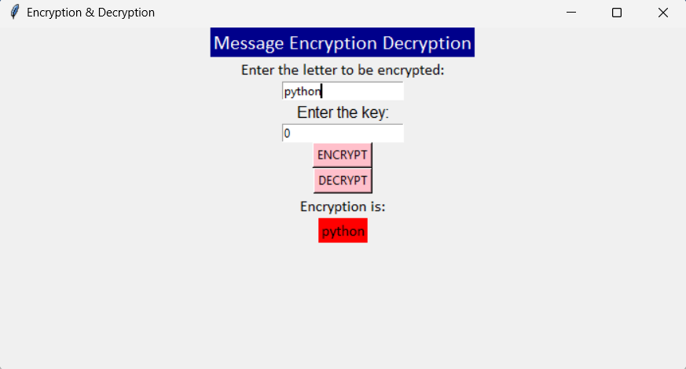

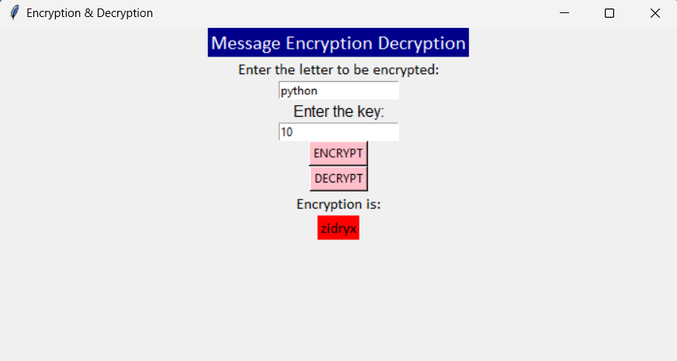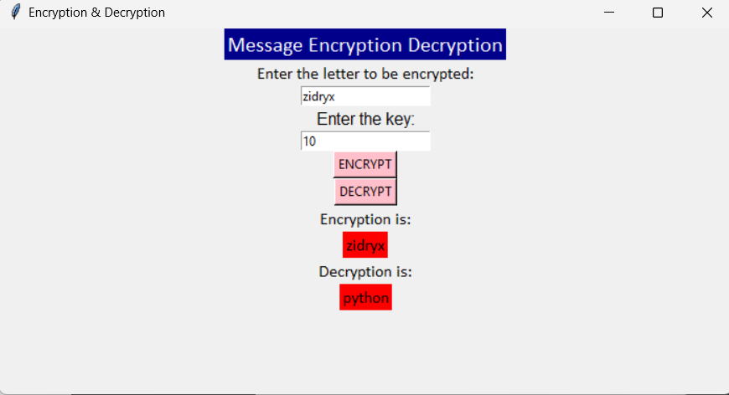

# Code link

<https://github.com/yuvrajxxx/Encryption-using-python/blob/main/encryption%20decryption.py>

# Summary

The above code demonstrates how to create and run a basic Encryption/Decryption code using the Tkinter library in python.

Thank you!!!